

Guía de Instalación

Participantes:
Adrià Mondéjar 25%
Sergio Gonzalez 25%
Marc Picazos 25%
Javier Bufo 25%
Ciclo formativo: 2n DAW
Año: 2014 – 2015 - 28/05/2015
Índex de continguts
Minimum requeriments: 3
System requirements 3
Software requirements 3
User knowledge requirements 3
Installation 4
XAMPP Installation 4
Install composer 11
Install System Scheluder 15
Project installation 19
Create database 19
Deploy main project 22
Create database 25
Filling the database 26
System Scheduler configuration 29
F.A.Q. 34
What is Composer 34
What is XAMPP 34
What is System Scheduler 34
What is Laravel 34
I want to install the project on another SO 34
Incomplete data on the webpage 34
Can I use other email service ? 34
Maintenance 34

Minimum requeriments:

System requirements
Operating system: Windows® XP / Windows® Vista® / Windows® 7 / Windows® 8 (updated with the last service pack)
CPU: Intel® Core™ 2 Duo E6600 or AMD Phenom™ X3 8750
RAM: 2 GB RAM (1 GB Windows® XP)
500MB HDD free space
An Internet connection

Software requirements

Xampp → https://www.apachefriends.org/es/index.html
PHP 5.5 → http://php.net/get/php-5.5.25.tar.bz2.asc/from/a/mirror
Composer → https://getcomposer.org/download/
Node.js
Web browser (Google Chrome, Firefox, Internet Explorer ..)
System Scheduler
Project package downloaded: https://github.com/TroyerPro/proyectoFinal/

User knowledge requirements

Basic requirements
-Basic web browser knowledge
-Minimum concepts of Windows line commands

Advanced requirements
-Knowledge about programming and code.
-Experience using frameworks (preference: Laravel).

Installation

XAMPP Installation
We go to this URL and download XAMPP:
https://www.apachefriends.org/es/index.html

Select your language and then press the OK button:

Select all options and press next:
Select the installation path, (it's highly suggested to not touch it and leave it as C:\xampp) and press install:

We have almost finished the installation proccess. Let it work for a while.

And finally.. TANANA! We got XAMPP installed and fully working! ;)

Install composer
We need to install composer. Go to this link: https://getcomposer.org/download/ and download the executable for windows (composer-installer.exe), and then execute it.
This is the welcome composer setup. Now click on the “Next >” button:

We don't want to install shell menus (unnecessary) so we click on “Do not install Shell Menus” and next button:

Select the path where you installed XAMPP and search the folder PHP, then select php.exe (if you installed it on the default directory just don't change it) and press next button:
Click install button! We are almost done installing composer:

Let the progress bar finish and...
TANANA! Finally we got Composer installed:

Install System Scheluder
Go to http://www.splinterware.com/download/index.htm and download System Scheluder

Now launch the file we downloaded. We'll get the welcome setup view as in the next preview image. Press next button to continue.

Select the path where you want System Scheduler to get installed:
Press install:

Let the setup do his job:

TANANA! We got our System Scheduler configurated!

Project installation

Create database
Launch XAMPP control panel
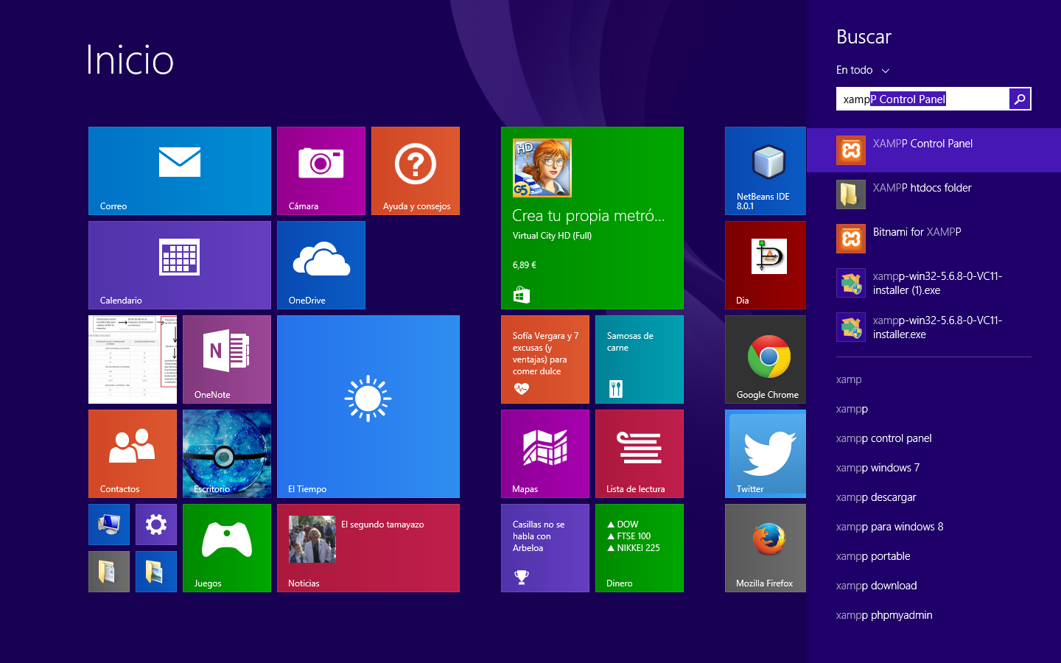
Press start MySQL and Apache

Type localhost/phpmyadmin on the web browser and click on new (Nueva) on the left side

Put the name you want to the database and select the utf8_general_ci on the dropdown, then press create. In our case, we'll use ret .

Deploy main project
First of all, we need to download the project package on: https://github.com/TroyerPro/proyectoFinal/

Go to your XAMPP folder → htdocs and extract the ZIP here (C:\xampp\htdocs by default). If you want the extract only the project just extract the path of the ZIP: //project/ret2

Let's open the cmd and go to this directory with the command cd C:\xampp\htdcos\ret2

Type the command “composer install” and let him work (it will take its time):

After composer finish, type “nms install” on the root to install dependencies from node.js (it will take a while)

Now copy the env.exemple on the directory ret2:

Open the copy of .env.exemple and configure it:

The result will be similar to this:

Save it and rename the file you have modified to .env:

Create database
After composer install has FINISHED
Make sure XAMPP is working with Apache and MySQL started

Type the command php artisan migrate on the path of the project:
It will make the tables of the database automatically

Before the command make sure you check the database is empty:

After that, you can see the tables that have been created:

But they are still empty: althrough there's no data inside the tables, the project will work. However, it is highly recommended to seed the database for an easier knowledge of the project.

Filling the database
This is optional, but it is highly recommended to do, go to the path of the project and write
php artisan db:seed

By doing this, the tables will seed up and filled with data:

You can check it now on the database, just select one table and see it's filled with data:

You can check the project is currently working by typing this on your web brower: http://localhost/ret2/public/

System Scheduler configuration
Open System Scheduler

Click on add button:

Set the the title of the work and select the application, the application is on the root of the project, the name is system.bat

Then click on schedule and select schedule type: every minute:

Click on save and exit or press F4:

You can START/DISABLE the event pressing F4 or right click on the event:

Mail Configuration
In this case we use Mailgun but you can use other service like gmail or mandril to send emails . First of all you need to make account in Mailgun ( http://www.mailgun.com/ ).
After you create one domain you will get this , this is all the information of your mailgun domain and you will need in the configuration :
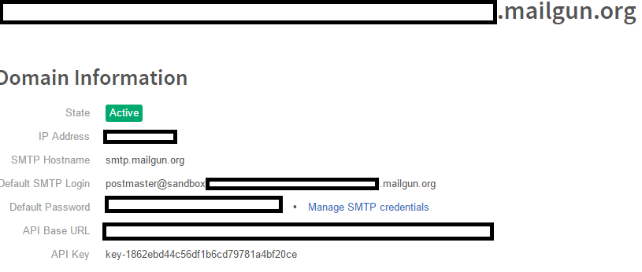

This is the domain information with you api-key , login , password , etç
Now go to config/mail.php , and configure like this :
'driver' => 'mailgun',
'host' => 'smtp.mailgun.org',
'port' => 587, 'from' => ['address' => 'youradress@gmail.com', 'name' => 'Your Name'],
'encryption' => 'tls',
'username' =>'mailgun domain Smtp login',
'password' => 'mailgun domain password',
'sendmail' => '/usr/sbin/sendmail -bs',
'pretend' => false,

Now go to config/services.php , and configure like this :
'mailgun' => array( 'domain' => 'your mailgun domain',
'secret' => 'key-yourdomainmailgunkey', ),

Remembre you can get all this information in your Mailgun Domain Information.

F.A.Q.

What is Composer
Composer is a software tool that makes easy to install dependences (PHP) on a project, to make more easy the installation of a project, when you do a composer install it checks de composer.json file to see the dependences, composer download the dependences and install it.

What is XAMPP
XAMPP is a open source cross-plataform web server solution stack package, consisting mainly on Apache + MySQL services. It gives you a simply way to make a web service.

What is System Scheduler
System Scheduler is a way to make automatic jobs on a system, you can program one job to be executed every X minutes, days or months.

What is Laravel
Laravel is free open-soruce PHP web application framework, it's used for the development of web applications following the MVC architectural pattern, general laravel features are include expressive syntax, modular packaging system, different ways for accessing relational databases and various utilities that aid in application deployment and maintenance.

I want to install the project on another SO
You can install XAMPP on others SO, like Linux or MAC, you can check the alternative downloads on: http://www.apachefriends.org/en/xampp.html

Incomplete data on the webpage
Seems like a problem with the database seed or database migration, you will to delete the database and do the database migration and seed again.

Can I use other email service ?
Yes , you can use other email service , in this project we use mailgun as default but you can use gmail or mandril.

Maintenance
The project dont need maintenance, if you want keep the componentes updated you can do a composer update every month. In the future we can made a backup system, that makes database backups for security.

